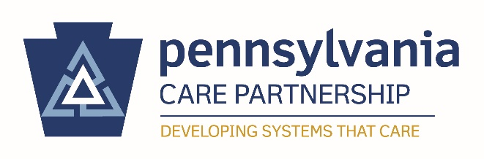

Participation Agreement
CLC Pilot Project

County/Department/Organization: ________________________________________

County/Department/Organization Lead: ____________________________________

RE: CLC Pilot 3.0 Participation Agreement

Period Covered: August 2019 – June 2019

_____ [County/Department/Organization] _________ agrees to participate in the Pennsylvania Care Partnership Cultural and Linguistic Competency Pilot Project 3.0. Participation is completely voluntary and aims to support PA Care Partners in the development of their CLC Programming through targeted technical assistance and networking. Involvement in the CLC Pilot 3.0 encourages PA Care Partners with demonstrated CLC leadership capacity and CLC experience, to mentor and support one another as pilot project participants. During the CLC Pilot 3.0, participants engage in the equivalent of 15 hours of CLC training. Furthermore, participants are committed to the best of their ability to implementing a CLC action item after conducting an assessment and developing a CLC plan. The PA Care Partnership is fully committed to supporting pilot participants throughout their CLC journey and looks forward to sharing their successes.

Pilot Participant Signature__________________________________

Date___________________________________

DEADLINE

Participation agreements should be uploaded via SurveyMonkey application no later than Friday, August 9, 2019, 5:00 p.m.

For assistance with this application or for further information, please contact:
Kelsey Leonard, Cultural and Linguistic Competence Coordinator
Email: leonardkt@upmc.edu

