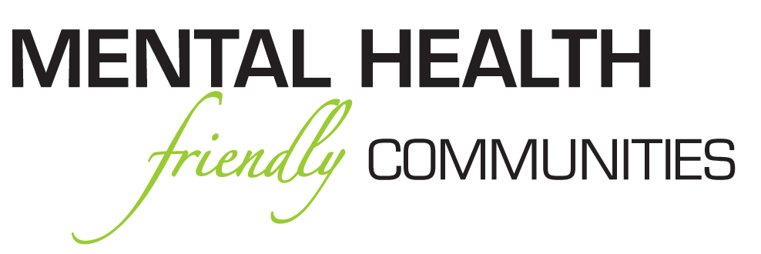

MHFC TEN COMMITMENTS

The Pastor, leadership and members of

(Name of Church Here)

Commit to our members and community to…

- Commit To Eliminating Mental Health Stigma, Discrimination And Improving Outcomes For Consumers And Family Members Of Our Congregation

- Develop A Mental Health Ministry

- Host Regular Mental Wellness Fireside Chats For Our Members And Community

- Host An Annual Mental Wellness Training Event

- Will Recognize And Promote The National Week of Prayer For Mental Wellness The First Full Week Of October and the Day of Prayer that Tuesday

- Will Recognize And Promote Mental Wellness Awareness Month (May)

- Utilize Mental Wellness Friendly, (People First) Language In Our Teaching, Preaching And Ministries,

- Will Dedicate At Least Two Messages Annually To Mental Wellness

- Foster, Cultivate And Develop Collaborative Relationships With Local Like Minded Organizations Committed To Promoting Mental Wellness In The African American Community

- Will Incorporate Mental Wellness Training In Church Wide Events, Retreats And Workshops

"The most important evidence based practice is "LOVE" the most often successful is PRAYER!" Gigi R. Crowder (2013)

