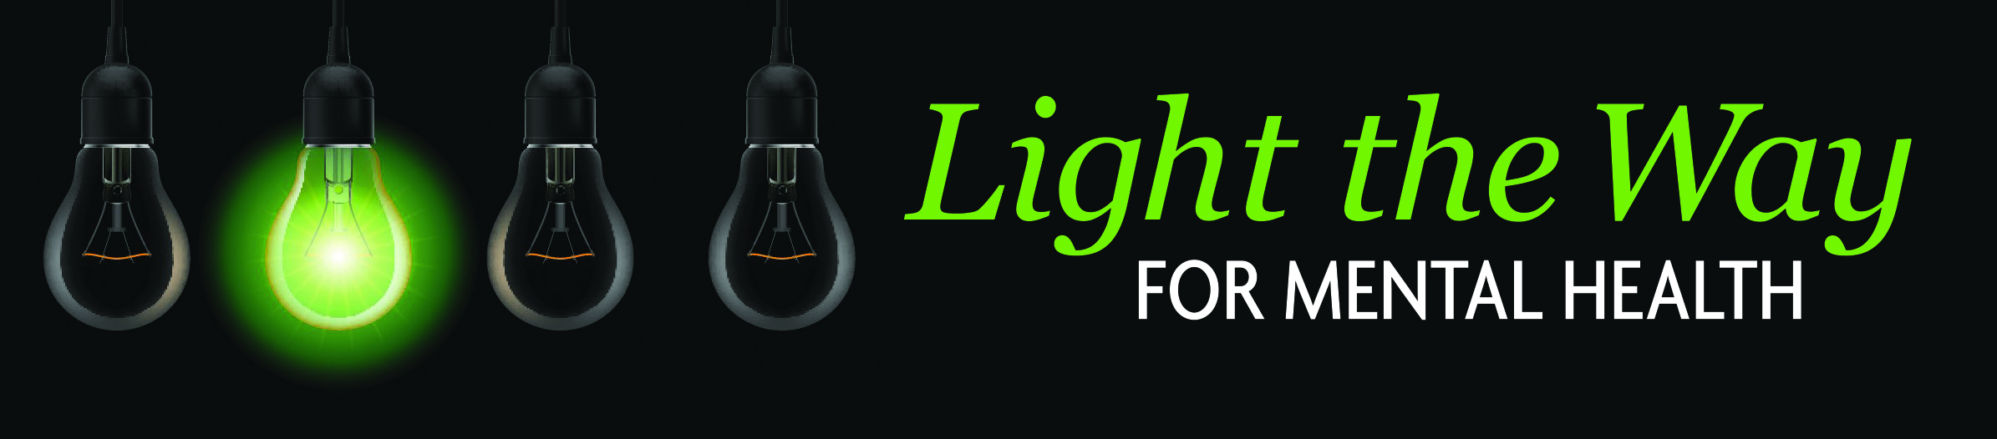
May is Mental Health Awareness Month
2nd A n n u a l G R E E N L I G H T C A M P A I G N !
Monday, May 6th to Sunday, May 12th

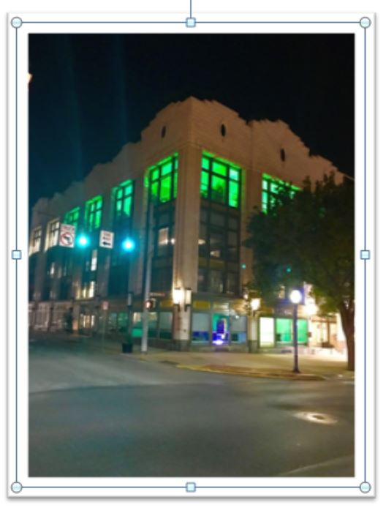
Greetings:
Just a friendly reminder: For those of you who participated last year, it is time to unpack your green lights and place them in your windows for this entire week to help raise awareness about mental health!

The System of Care (SOC) is launching its 2nd annual Mental Health Awareness Campaign in collaboration with human service providers, businesses, churches and schools from Monday, May 6th to Sunday, May 12th.

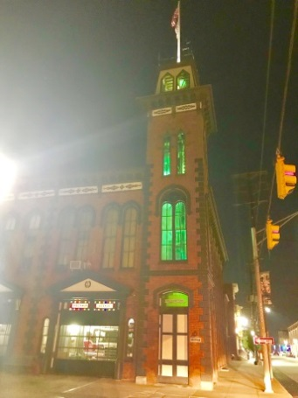
The purpose of this campaign is to raise awareness about mental health, but more importantly, to spark conversations and fight the stigma surrounding mental health.

You can help shine the light on mental health by one simple gesture of changing your lights green!

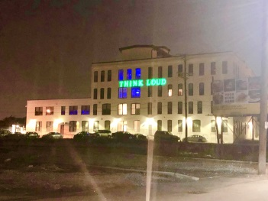
If you are new to this green light campaign, or if you no longer have your lights from last year, please email me at cigo@yorkcountypa.gov. We still have a limited supply of string lights and bulbs available that we would be happy to drop off to you, while our supplies last.

Thank you, in advance, for your participation.

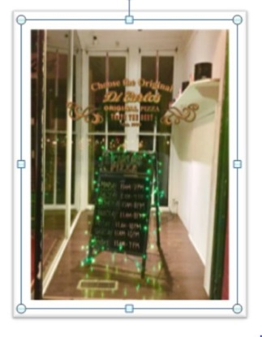
Regards,
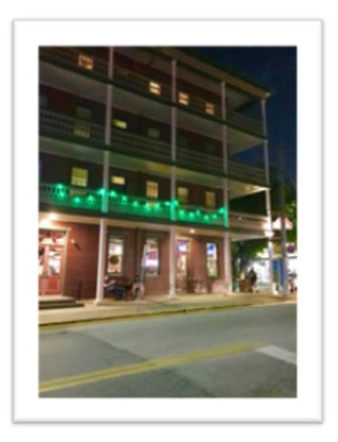
Colleen Igo
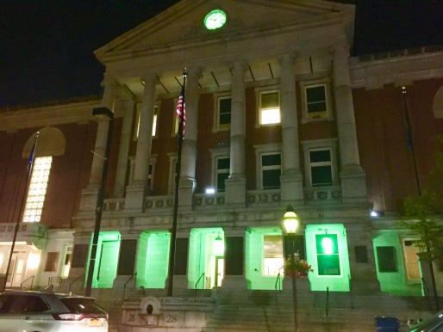
System & Community Initiative Manager
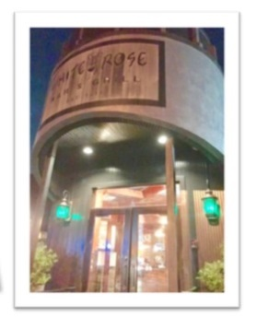
York County Human Services Department
100 West Market St., Suite 401 | York, PA 17401
Cell: 717-324-1012
CIgo@YorkCountyPA.gov

